Company Summary
Third coast bancshares, inc. (Nasdaqgs: Tcbx)
Research Update
Dave Storms, CFA
dave@stonegateinc.com
214-987-4121

Financial Results: For 2Q24 Third Coast reported net income of $10.8M, up from $10.4M in 1Q24. This was equal to a basic and diluted EPS of $0.70 and $0.63, respectively. The Q/Q increase was mainly driven by higher net interest income due to increased loan rates, higher non-interest income, and ongoing savings from cost-cutting efforts implemented in previous quarters. However, this rise in net income was partially balanced out by a slightly greater provision set aside for credit losses during the quarter. We expect the Company to keep operational efficiency a focus for the foreseeable future to help navigate the current macro environment.

Interest Income and Expenses: TCBX reported a net interest margin of 3.62% for the quarter, which is up from 3.60% in 1Q24. We note that this remains elevated compared to average comps NIM of 2.58%. Year over year NIM declined from 3.82% primarily due to a 48.0% increase in expenses that outweighed the 14.0% year over year increase in interest income.

Deposits and Loans: The Company’s loan portfolio remains on strong footing with growth of $422.9M year over year. Over that same period net deposits increased by $447.3M. The Company did see an increase in non-performing assets, split between an increase of $5.8M of non-accruals and a $2.9M decrease of loans over 90 days past due. The increase in non-accruals is related to 5 relationships placed on non-accrual totaling $7.9M, offset by $2.1M worth of loan charge-offs in the quarter. Net charge-offs for the quarter were $1.8M. Lastly, we note that the quarter end book value and tangible book value were $26.99 and $25.60, respectively. This was up from 1Q24 values of $26.18 and $24.79.

Financial Ratios: At the end of 2Q24, tier 1 capital ratio was 9.88%, up slightly from 9.54% in 1Q24. Third Coast’s non-performing loans to total loans percentage was 0.65%, a slight increase from 0.58% in 1Q24 due to the factors discussed above. Additionally, TCBX had a ROAA and ROAE of 0.97% and 10.53%, respectively. The efficiency ratio for the quarter was 61.39%, down from 64.11% last quarter. The Bank currently has $253.9M in cash and equivalents, which is equal to $18.59 per share or approximately 148% of the stock value.

COMPANY DESCRIPTION
Third Coast Bancshares, Inc. is a commercially focused bank founded in 2008 with its headquarters in Humble, TX. Third Coast provides a variety of banking and lending services between the cities of Dallas, Houston, and San Antonio. The Company serves institutions, businesses, individuals, and families in 5 markets with 18 branch locations across Eastern Texas. The Bank began trading on the Nasdaq GS exchange in November of 2021 under the ticker symbol TCBX.
Growth Initiatives: Growth has been seen through the first half of the year with the Company opening the 17th and 18th branch locations. Management also noted that the Company continues to execute strategic objectives, as was mentioned earlier with regards to operational efficiency. Additional priorities include diversifying the deposit portfolio and managing expenses. It is expected that this, combined with a strong loan pipeline, will lead to continued growth.

Valuation: We use a comp analysis on P/E and P/BV to frame our valuation of TCBX. Using a forward P/E range of 9.0x to 11.0x with a mid-point of 10.0x on FY25 estimates results in a valuation range of $21.44 to $26.21 with a mid-point of $23.83. Using a P/BV range of 1.0x to 1.1x with a mid-point of 1.1x results in a valuation range of $26.99 to $29.69 with a mid-point of $28.34.

Business Overview

Third Coast Bancshares, Inc. (“the Company”, “the Bank”, “TCBX”, or “Third Coast”) is a commercially focused bank founded in 2008 with its headquarters in Humble, TX. Third Coast provides a variety of banking and lending services between the cities of Dallas, Houston, and San Antonio. The Company serves institutions, businesses, individuals, and families with 18 branch locations across Eastern Texas. The Bank began trading on the Nasdaq exchange in November of 2021 under the ticker symbol TCBX.

Exhibit 1: Company Location
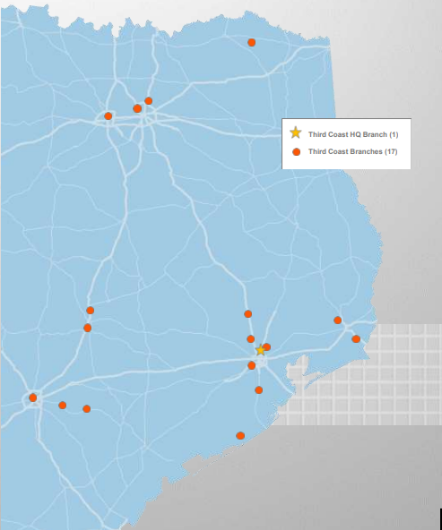
Source: Company Reports
The Bank is primarily involved in the business of attracting deposits in the Bank’s market areas. The Bank grows by investing these deposits, as well as other sources of funds, in loans that are secured by commercial and residential real estate, business assets, and personal guarantees. Third Coast has kept itself competitive by offering competitively low rates, maintaining a strong team-oriented culture, and organic growth stemming from customer attentiveness.

Third Coast further diversifies its revenue base through several specialty lending verticals such as SBA loans and working capital solutions loans. These revenue streams fall under the Noninterest Income category along with service charges and fees on deposit gains, earnings from bank owned life insurance, and derivative fees. While these lines make up a proportionally small amount of the income when compared to interest income, we are encouraged by the Banks ability to further serve customers, which we believe strengthens customer relations.

The Bank’s performance is tied to its three markets. These markets are broken out further below, with one additional branch in Detroit, TX which is approximately 120 miles northeast of Dallas, TX:

Dallas-Fort Worth Market – The Company has three branches in the Dallas-Fort Worth market, with one location in the North Dallas area, one in Plano, and one in Fort Worth. The DFW Market is the largest in Texas and the fourth largest in the U.S. and boasts the sixth largest GDP in the nation. This area hosts approximately 3.6m working professionals and is among the top ranked areas for job growth in the nation.

Greater Houston Market – The Company has nine branches in the Greater Houston market, including seven branches located in the Houston MSA and two branches in the neighboring Beaumont MSA. The Houston MSA is projected to grow by 7.6% over the next 5 years, which is more than double the nationwide projected growth. The Beaumont MSA is highlighted by an influx of industrial, infrastructure, and commercial projects as well as its strategic location along the gulf coast.

Austin-San Antonio Market – The Company has five branches in the Austin-San Antonio market, with one location in Georgetown, one in La Vernia, one in Nixon, one in De Novo, and one in San Antonio. The Austin MSA is projected to grow 8.5% through 2026 and was recently designated a top 10 global Technology Innovation Hub city by KPMG. San Antonio is projected for a population growth of 7.6% over the next 5 years.

Exhibit 2: Loan Portfolio
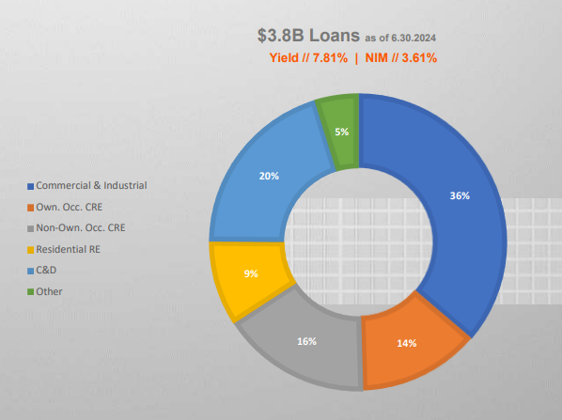
Source: Company Reports as of 07/25/2024
Loan Portfolio

Third Coast’s primary source of revenue is generated by providing loans to commercial and retail customers in the above-mentioned regions of Texas. TCBX primary lending activities originate from commercial and residential real estate lending. At 2Q24 end, Third Coast’s loan portfolio was $3.8B at a yield of 7.81%. The Bank’s loan portfolio primarily consists of Commercial and Industrial loans. This was an increase of $12.0M from 1Q24.

Third Coast has a robust commitment to sound underwriting and comprehensive monitoring across its lending portfolio. At the community banking level this takes the form of reviewing and verifying compliance with loan covenants. At the corporate banking level, trend cards are kept on every borrower with over $10.0M which includes quarterly reviews on income statements and balance sheet metrics as well as applicable ratios. The team also does quarterly meetings to review all borrowers.

Deposits

Deposits are the primary source of funds for the Bank to use in its lending and investment activities. Third Coast’s deposits come from individuals and businesses who reside in the Texas MSA’s highlighted above. The Bank offer various deposits including:

- Checking
- Savings
- Money Market
- Individual Retirement Accounts
- CDs

Total deposits in 2Q24 were $3.86B versus $4.05B in 1Q24, decreasing by approximately 4.8%.

Exhibit 3: Balance Sheet Growth
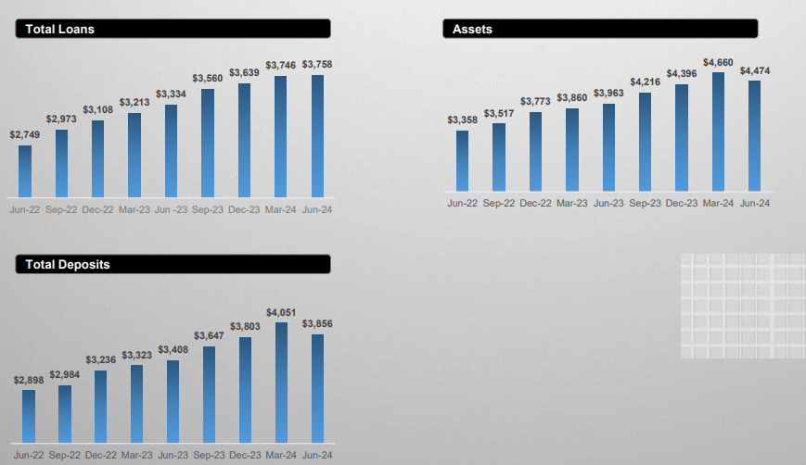
Source: Company Reports as of 07/25/2024
Profitability

Exhibit 4: NIM Trends vs Peers
Source: Company Reports

Net interest margin (NIM) is a good indicator of how profitable banks are through their investments. Exhibit 4 provides TCBX’s net interest margin trends relative to its peers since 1Q20.

We note that TCBX has maintained NIM outperformance compared to peers since COVID, and we expect this trend to continue. NIM has remained above 3.6% since 2Q22 despite the elevated rate environment. As of 2Q24 TCBX NIM was 3.62%, which continues to outpace its peers. We expect this strong NIM performance to be maintained, with the potential to increase in the event of a falling rate environment.

We note that in 3Q23, TCBX experienced a spike in its efficiency ratio, which was impacted by a decision to reduce operating expenses and overhead costs leading to a significant one-time severance expense. This was a strategic decision by Third Coast to set the Bank up for future growth. Since this blip in 3Q23 we have seen both efficiency ratio and ROAA return to normal levels.

Exhibit 5: Profitability Trends
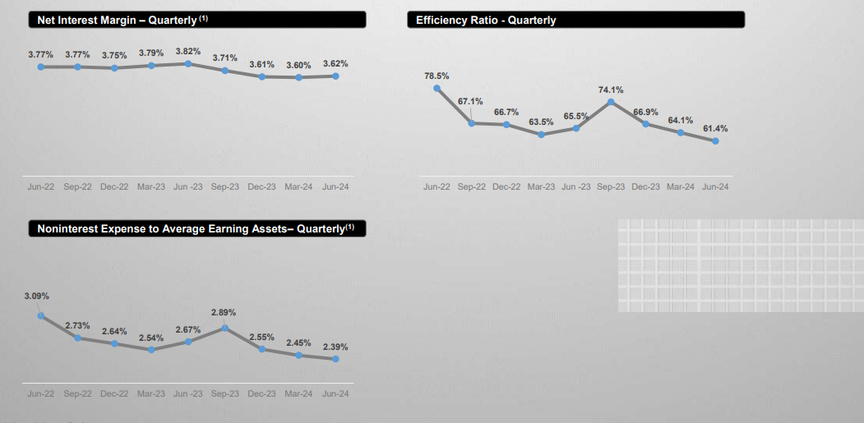
Source: Company Reports as of 07/25/2024

Growth Initiatives
While the Company has a focus on organic growth, the Bank has also shown a willingness and ability to grow externally. This was displayed in 2020 when TCBX merged with Heritage Bancorp, Inc. Organic growth will be driven by strategic hires and the opening of new branches. We also expect TCBX to continue expanding products and services with further investment in technology to deliver quality customer experiences. This, in combination with the Bank’s broad-based community values, is expected to grow core deposits.
Risks

Geographic concentration – Third Coast is concentrated in the state of Texas, which exposes it to risks associated with lack of geographic diversification. A local or regional economic downturn could adversely affect the Company’s profitability.
Changes in interest rates – Third Coast’s results depend on its net interest income; should the rates it earns on loans, securities and other interest-bearing assets fluctuate faster than the rates it is required to pay on deposits and borrowed funds, results would suffer.
Security of systems – Any material breaches in the security of Third Coast’s banking systems could cause material losses for the Bank. Protecting sensitive consumer data is essential as is maintenance and backup of key financial and customer information.
Access to future capital – Should the Company incur significant loan losses, desire to execute acquisitions, or require additional funds for other operational purposes, the timing and terms of the capital may not be favorable given certain economic and/or market conditions.
External shocks – War, terrorism, other acts of violence or natural or manmade disasters such as a global pandemic may affect the markets in which the Company operates, the Company's customers, the Company's delivery of products and customer service, and could have a material adverse impact on our business, results of operations, or financial condition.

VALUATION SUMMARY

Third Coast’s experienced management and service teams bring not only valuable industry knowledge, but also a unique grasp of the local economy and target demographics. This experience, coupled with the Company’s operating ability, should allow it to take advantage of any opportunities that may present themselves.

Price / Earnings
Comparable companies are trading at an average of 12.3x FY25 P/E. We believe TCBX should trade in a forward P/E range of 9.0x to 11.0x with a mid-point of 10.0x. Using this range on our FY25 EPS estimate results in a valuation range of $21.44 to $26.21 with a mid-point of $23.83.

Price / Book Value

Third Coast is trading at 0.9x P/BV vs. comps at 1.2x. We believe TCBX should trade in a price to book value range of 1.0x to 1.1x with a mid-point of 1.1x. This will bring TCBX in line with comps. Using this range on current book value per share results in a valuation range of $26.99 to $29.69 with a mid-point of $28.34.

BALANCE SHEET
INCOME STATEMENT

IMPORTANT DISCLOSURES AND DISCLAIMER

- The research analyst and/or a member of the analyst’s household do not have a financial interest in the debt or equity securities of the subject company.
- The research analyst responsible for the preparation of this report has not received compensation that is based upon Stonegate’s investment banking revenues.
- Stonegate or any affiliate have not managed or co-managed a public offering of securities for the subject company in the last twelve months, received investment banking compensation from the subject company in the last 12 months, nor expects or receive or intends or seek compensation for investment banking services from the subject company in the next three months.
- Stonegate’s equity affiliate, Stonegate Capital Partners, “SCP” has a contractual agreement with the subject company to provide research services, investor relations support, and investor outreach. SCP receives a monthly retainer for these non-investment banking services.
- Stonegate or its affiliates do not beneficially own 1% or more of any class of common equity securities of the subject company.
- Stonegate does not make a market in the subject company.
- The research analyst has not received any compensation from the subject company in the previous 12 months.
- Stonegate, the research analyst, or associated person of Stonegate with the ability to influence the content of the research report knows or has reason to know of any material conflicts of interest at the time of publication or distribution of the research report.
- No employee of Stonegate has a position as an officer or director of the subject company.

Ratings - Stonegate does not provide ratings for the covered companies.
Distribution of Ratings - Stonegate does not provide ratings for covered companies.
Price Chart - Stonegate does not have, nor has previously had, a rating for its covered companies.
Price Targets - Stonegate does not provide price targets for its covered companies. However, Stonegate does provide valuation analysis.

Regulation Analyst Certification:
I, Dave Storms, CFA, hereby certify that all views expressed in this report accurately reflect my personal views about the subject company or companies and its or their securities. I also certify that no part of my compensation was, is, or will be directly or indirectly related to the specific recommendations or views expressed in this report.

For Additional Information Contact:
Stonegate Capital Markets, Inc.
Dave Storms, CFA
Dave@stonegateinc.com
214-987-4121

Please note that this report was originally prepared and issued by Stonegate for distribution to their market professional and institutional investor customers. Recipients who are not market professional or institutional investor customers of Stonegate should seek the advice of their independent financial advisor prior to taking any investment decision based on this report or for any necessary explanation of its contents. The information contained herein is based on sources which we believe to be reliable but is not necessarily complete and its accuracy cannot be guaranteed. Because the objectives of individual clients may vary, this report is not to be construed as an offer or the solicitation of an offer to sell or buy the securities herein mentioned. This report is the independent work of Stonegate Capital Markets and is not to be construed as having been issued by, or in any way endorsed or guaranteed by, any issuing companies of the securities mentioned herein. The firm and/or its employees and/or its individual shareholders and/or members of their families and/or its managed funds may have positions or warrants in the securities mentioned and, before or after your receipt of this report, may make or recommend purchases and/or sales for their own accounts or for the accounts of other customers of the firm from time to time in the open market or otherwise. While we endeavor to update the information contained herein on a reasonable basis, there may be regulatory, compliance, or other reasons that prevent us from doing so. The opinions or information expressed are believed to be accurate as of the date of this report; no subsequent publication or distribution of this report shall mean or imply that any such opinions or information remains current at any time after the date of this report. All opinions are subject to change without notice, and we do not undertake to advise you of any such changes. Reproduction or redistribution of this report without the expressed written consent of Stonegate Capital Markets is prohibited. Additional information on any securities mentioned is available on request.

